Inner Power Camp Content

SECTION 1:
Layout Type: Full-width banner
Image:
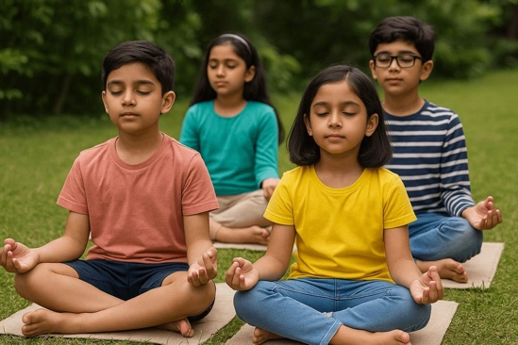 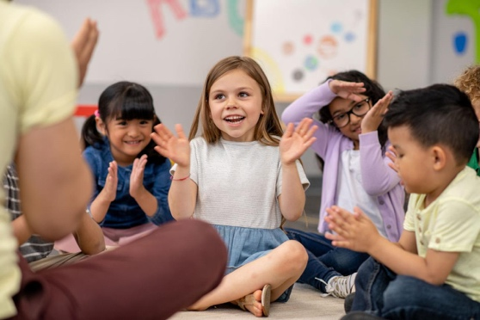
Height: 90–100vh
Content Alignment: Center-left (desktop) / center (mobile)

Content:
- H1: Inner Power Camp for Kids
- H2: Not just a summer camp — a foundation for life
- Paragraph:
A holistic experience designed to build confidence, emotional strength, and focus in children—through movement, mindfulness, creativity, and expression.
- Highlight Text (bold / accent color):
This is not about keeping children busy.
This is about shaping who they become.
- CTA Button:
Enquire Now (link to WhatsApp 6363606088)

🔷 [SECTION 2: ABOUT]
Layout Type: 2-column (50/50)
- Left: Text
- Right: Image

Content:
H2: About Inner Power Camp
Paragraph:
At Tattvam Niramaya, we believe childhood is where confidence, emotional strength, and focus are built.
This camp helps children connect with their inner world—while growing stronger in the outer world.

Image:
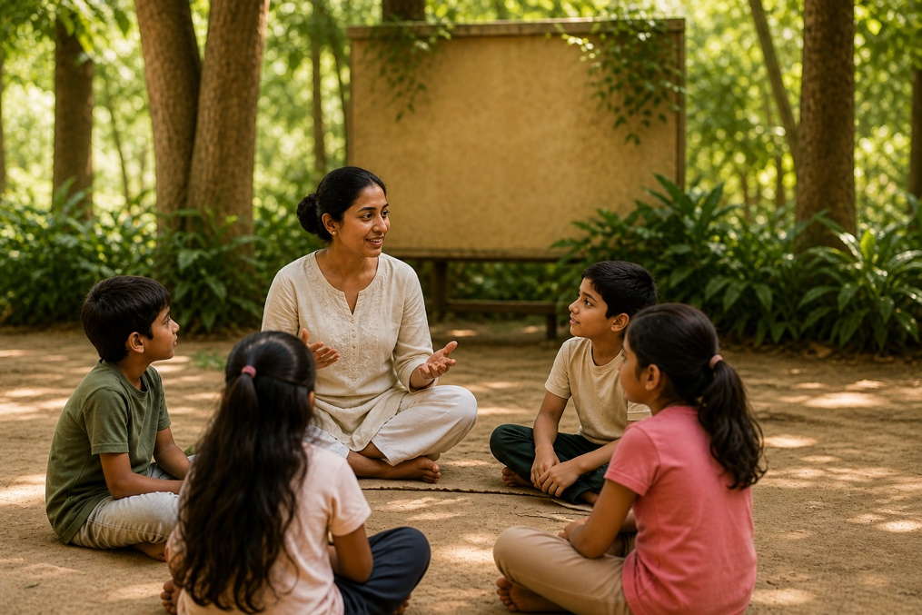

[SECTION 3: WHAT THIS CAMP BUILDS]
Layout Type: 4-column grid (desktop) / 2-column (tablet) / 1-column (mobile)

Each Card:
- Icon (top)
- Title (bold)
- No paragraph (keep crisp)

Content:
- Confidence in self-expression
- Emotional strength & awareness
- Focus & calmness
- Inner stability & resilience
Icon:
for each bullet point in content use the respective icons in the same order
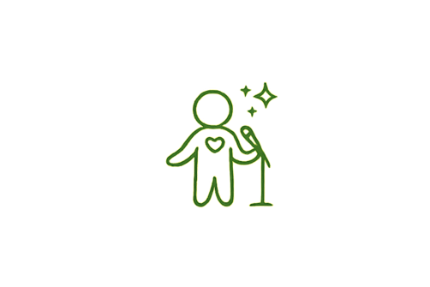


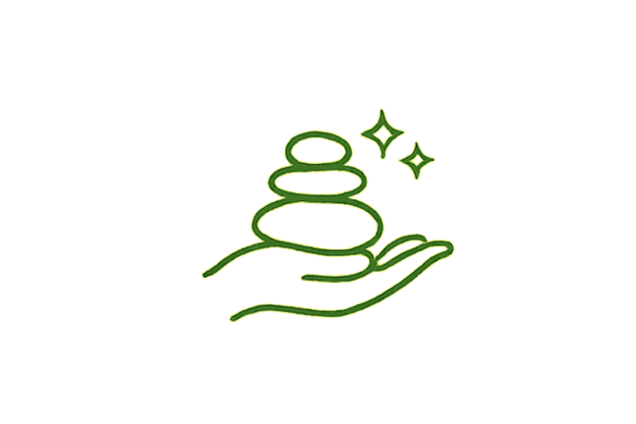

[SECTION 4: EXPERIENCE GRID]
Layout Type: Grid (3 columns desktop / 2 tablet / 1 mobile)
Card Style: Image top + text below

Each Card Structure:
- Image (1:1 ratio)
- H3 Title
- Short description (1–2 lines)

Cards:
- Warrior Movement (Kalaripayattu)
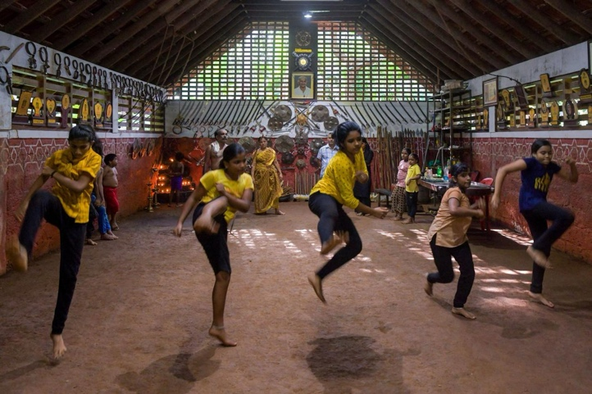
Builds strength, discipline, body awareness
- Mindful Yoga & Breathwork
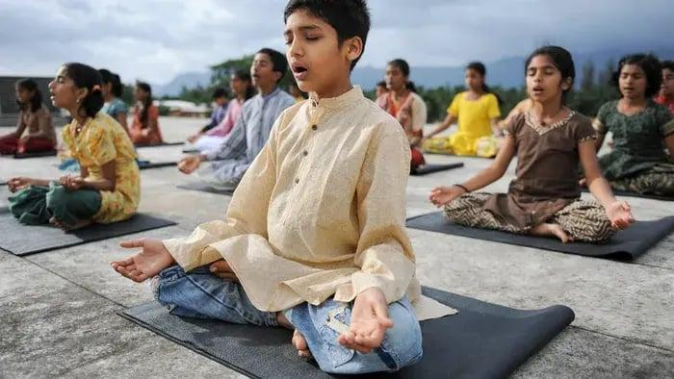
Improves focus and emotional balance
- Emotional Expression Theatre
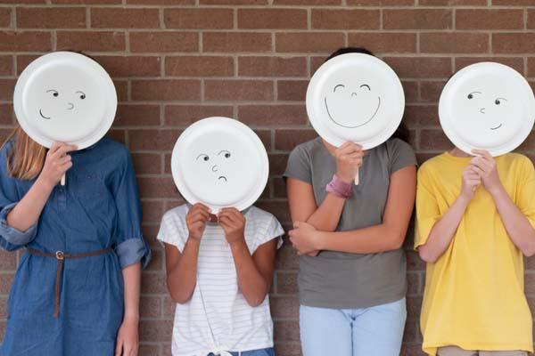
Helps children express through storytelling
- Sound Healing Experience
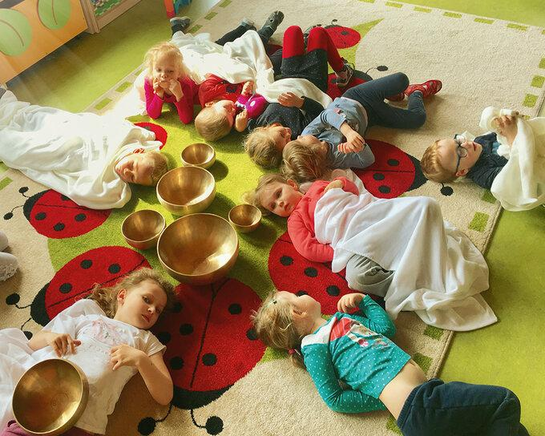
Calms mind and restores balance
- Confidence & Decision Lab
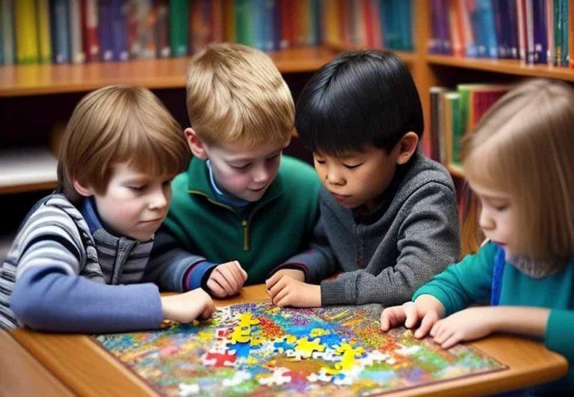
Builds decision-making and self-trust
- Sensory Art Expression

Encourages emotional release through creativity

[SECTION 5: OUTCOMES]
Layout Type: Full-width highlight section

Content:
H2: What Your Child Will Walk Away With
Bullet List (with icons):
- Express themselves with confidence
- Handle emotions better
- Stronger focus and calmer mind
- Feel grounded and inwardly strong

[SECTION 6: WHO IS THIS FOR]
Layout Type: Centered narrow container

Content:
H2: Who Is This For
Bullet List:
- Struggle with confidence or expression
- Easily distracted or anxious
- Need emotional grounding
- Want deeper growth beyond academics

[SECTION 7: WHY THIS CAMP IS DIFFERENT]
Layout Type: 2-column (text + image)

Left (Text):
H2: Why This Camp Is Different
Content:
This is not about keeping children busy.
It’s about helping them discover who they are.
Every activity is designed with purpose—blending ancient wisdom, modern psychology, and experiential learning.

Right (Image):
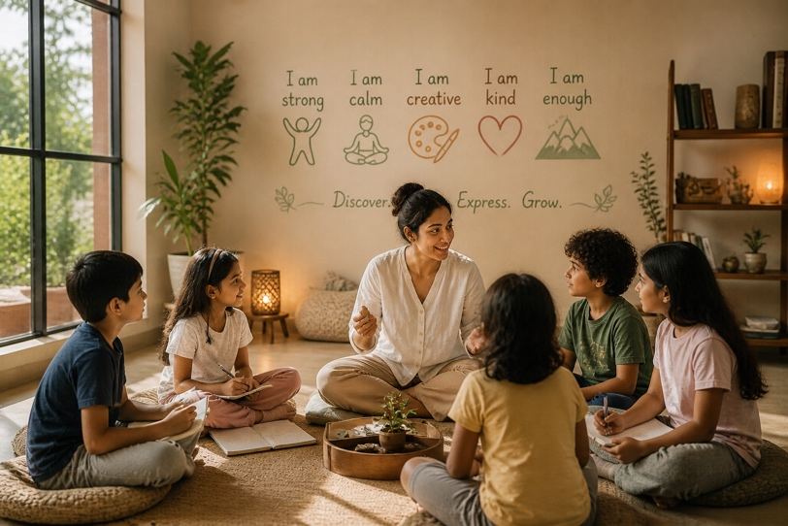

[SECTION 8: FINAL CTA]
Layout Type: Centered,

Content:
H2: Give your child something that stays for life
Subtext:
Not just skills. Not just activities.
A stronger, more aware human being.
CTA Button (Primary):
Enquire Now (Link to whatsapp button 6363606088)

